Enemy Spawner Mechanic tutorial

This tutorial will be focusing on making a way to spawn enemies. This can be attached to other mechanics but for the tutorial it is only the spawning mechanic. In addition, this is for if you are doing it for a 3D game.

To start this first create an empty game object. This will contain most of the code for the tutorial. Then create a normal game object. The object which will be the enemy can be anything but for this I used a cylinder.

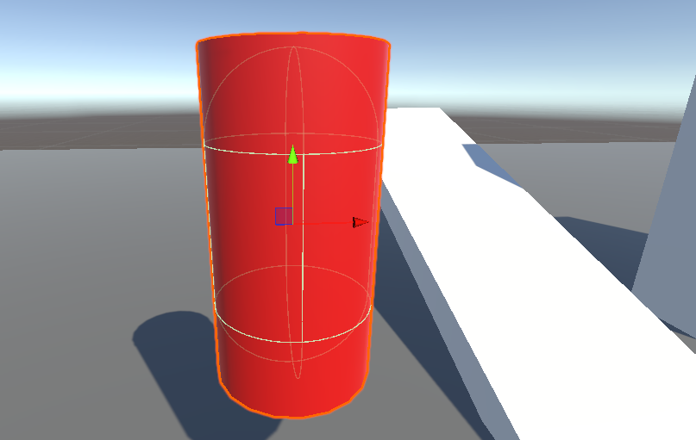

Once all objects are made create a c# script and attach it to the empty game object. Then write all these variables as seen in the image below.

The first one is used so the enemy is connected to the code. The second is used to tell how long each enemy will spawn, the bool one is not required but it is to be used to turn off the code. And finally, the last two are to limit how many will spawn.

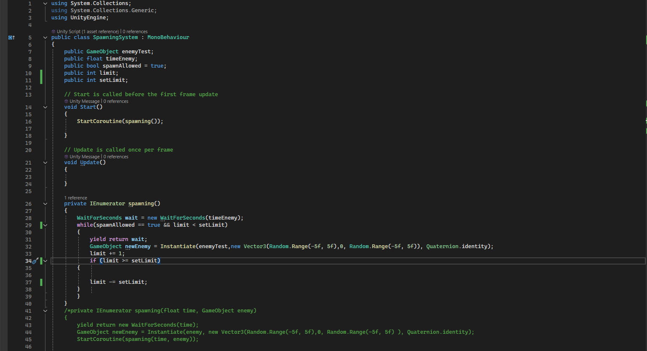

So, before writing the rest of the code, something will be used which if you understand, there will be no problem. This thing is using IEnumerator.

So now in the start function add this code line. This will start the function that will be using IEnumerator.



After that make a private new function following the image below. Once the function has been made add the first line of code which is to be used to limit how many will be spawned. Then make a while statement and in the bracket add the bull saying if it is true, and add next to it also saying if the “limit” int is less than the “setlimit” int. These are here so when one of these are not correct then the whole code stops.



After that in the while statement add a yield return wait so the time between each creation works. Then following the image below add that code line which will create the enemy at a random location based on the numbers in the code.



Once all of that is done there is only one simple thing to add. Under the last line of code add a small code where it increases the limit float by one each time an enemy is spawned. After that make an if statement like in the image below. This is used to test the mechanic. It resets the limit counter back to zero. Also, it must be here as it only works if it is in this function and not the update function.



Once all the code is done, it can be saved and tested in case of errors.

References:

<https://discussions.unity.com/t/simple-timer/56201>

<https://www.youtube.com/watch?v=SELTWo1XZ0c>

<https://www.youtube.com/watch?v=cecD66fZ_4c>

<https://www.youtube.com/watch?v=2PfJZtnfc_Q>

<https://www.youtube.com/watch?v=6Ai0xg6xTUk>

<https://www.youtube.com/watch?v=ydjpNNA5804>